**4**

**GROWTH AND DEVELOPMENT**

**Chapter coverage**

4.1 *Introduction of Growth and development*

4.2 *The concept of cell cycle*

4.3 *Measurement of Growth*

4.4 *Factors affecting Growth rate*

4.5 *Patterns of Growth*

*4.6 Growth in bacteria*

*4.7 Growth in plants*

**4.1 INTRODUCTION OF GROWTH AND DEVELOPMENT**

A human being is a kind of *miracle*. It begins as a single cell but the adult body contains many millions and millions of cells of different kinds. The changes that take place in an organism between fertilized egg stage and adult structure are referred to as growth and development. It is these twin processes of growth and development which are discussed in this chapter.

**Growth** can be defined as the permanent and irreversible increase in size and dry mass of an organism over a period of time. Growth does not include temporary increases in size resulting from, for example, drinking a lot of water or eating a large meal.

On the other hand, **development**, can be defined the progressive changes that take place in an organism from the conception to adulthood. It is therefore refers to the change in shape, form and degree of complexity that accompany growth. Growth and development commonly occur together and determine the overall changes in shape of an organism, a process called **morphogenesis**.

**Fig 4.1** **Differences between growth and development**

|  |  |
| --- | --- |
| **Growth** | **Development** |
| It is the permanent and irreversible increase in size and dry mass of an organism over a period of time. | It is the progressive changes that take place in an organism from the conception to adulthood. |
| It is quantitative in nature. | It is qualitative in nature |
| It stops at maturity | It proceeds throught the whole life |
| It leads to change in shape, form and body size | It leads to structural and functional change |

**4.2 THE CONCEPT OF CELL CYCLE**

**Cell cycle** is a series of events that occurs between one cell division and another. Typically, a mammalian cell takes about 24 hours to complete a cell cycle, of which about 90 % is interphase. It involves three (3) main stages that are **interphase**, **mitosis** and **cytokinesis** Fig 4.1.

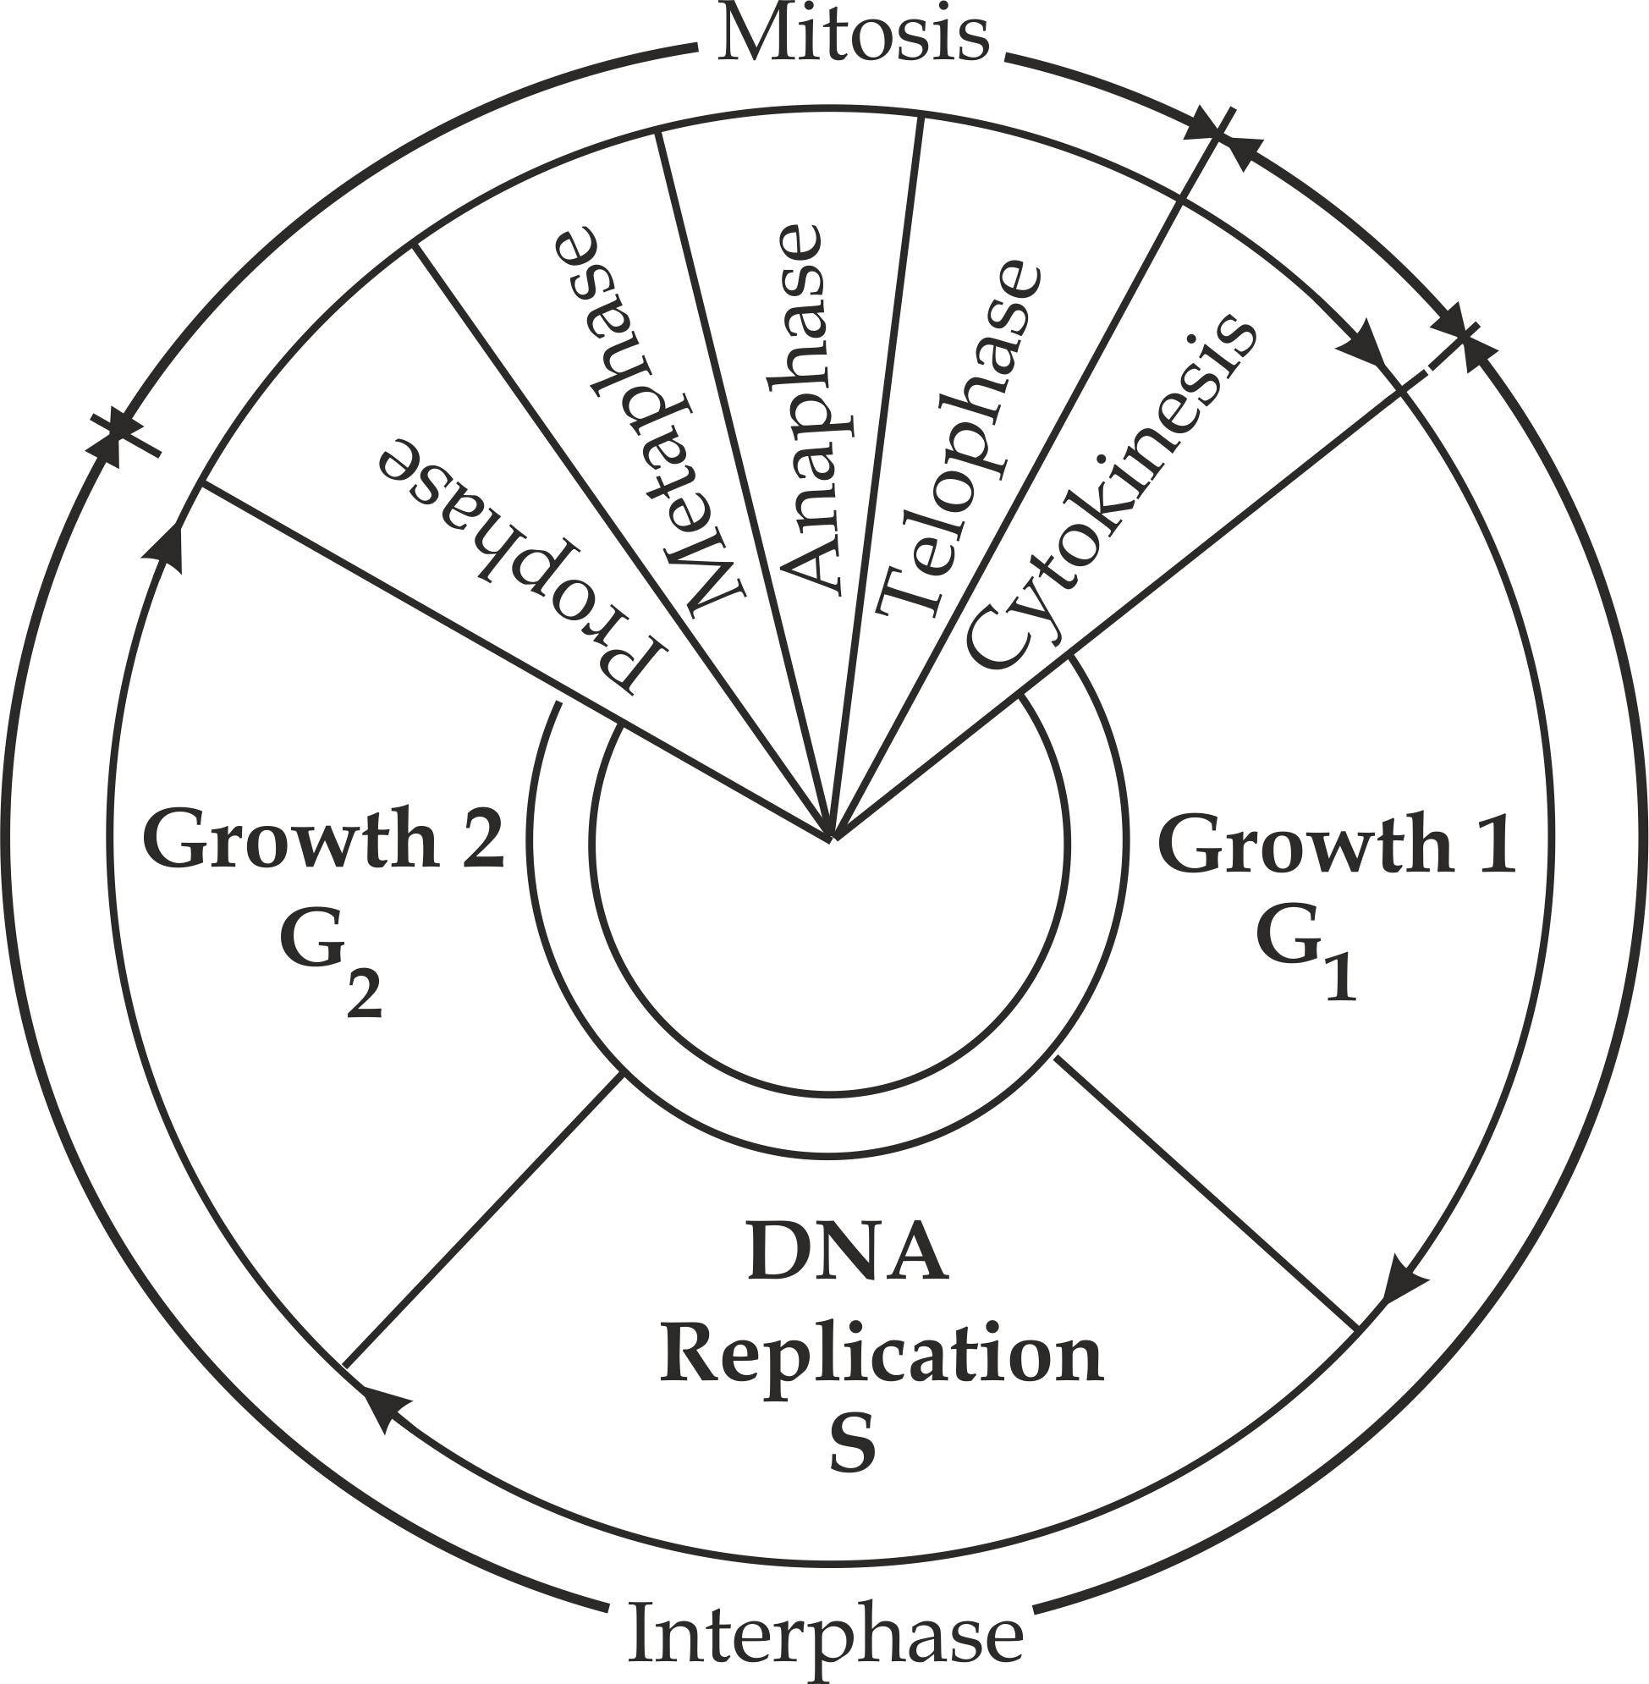

**Fig 4.1** The cell cycle

***Interphase***

**Interphase** is a non-dividing stage of the cell cycle during which a cell is preparing to enter mitosis. It is mistakenly referred to as the **resting stage**, however this is a mistake because the cell is carrying out intense chemical activity which takes place in the following phases of events – first growth phase (G1), synthesis (S) and second growth phase (G2).

1. **First growth phase (G1)**

This is the first growth period of the cell cycle during interphase which is characterized by the following events:

* There is cell growth in which cell increases in size.
* There is replication in cellular organelles except mitochondria and chloroplast.
* There is increase in metabolic rate in the cell.

1. **Synthesis phase (S)**

The synthesis phase is characterized by the following events:

* There is DNA replication to form two copies.
* There is synthesis of histone proteins and bound with each strand of DNA.
* There is replication of chromosome into two chromatids.

1. **Second growth phase (G2)**

This is the second growth period of the cell cycle during interphase which is characterized by the following events shown in Figure 4.2:

* There is replication of mitochondria and chloroplast.
* There is increase in energy store of the cell.
* Mitotic spindle fibres start to be formed.i.e, centrioles replicate.

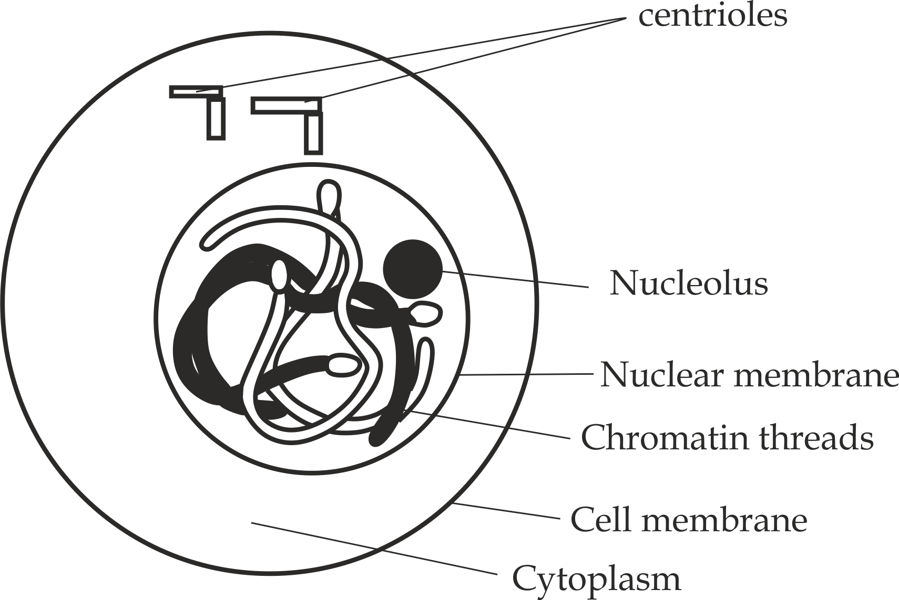

**Fig 4.2** interphase stage of mitosis

**SAQ 4.1**

**JECAS 2000**

* Interphase is a resting stage of the cell, negate or support this view with concrete reasons.

***Mitosis***

**Mitosis** is a type of nuclear division in which a parent cell is divided into two daughter cells carrying the same number of chromosome as parent cell.

**Significances of mitosis**

* It maintains **genetic stability** because daughter cells are identical to parent cells in number of chromosomes and no variation in genetic information.
* It is a means of **growth and development** in multicellular organisms such as mammals through an increase in the body size.
* It is a means of **asexual reproduction** in unicellular organisms such as protozoans through an increase in number of cells.
* It is a means of **healing** of wounds and replacement of worn out cells.
* It is a means of **regeneration** of body parts in some organisms such as a lizard tail or legs in crustacean.

**SAQ 4.2**

**JECAS 2008**

* Analyse five (5) significance of mitosis in living organisms.

**Phases of mitosis**

Mitosis is the second stage of cell cycle following interphase, it occurs in four consecutive phases namely – **prophase**, **metaphase**, **anaphase** and **telophase**.

1. **Prophase**

**Prophase** is the longest phase of mitosis which is characterized by the following events as shown in figure 4.3.

* The chromosomes become shorten, thicken and clearly visible as double chromatids held together by a centromere.
* In animal cells, the centrioles begin to move to the opposite poles of the cell and form the star shaped microtubule structures called asters, some of these microtubules called spindle fibres, may be seen extending across the cell from one pole to another. In plant cells, there are no asters.
* At the end of prophase, nucleolus and nuclear membrane (envelope) disintegrate.

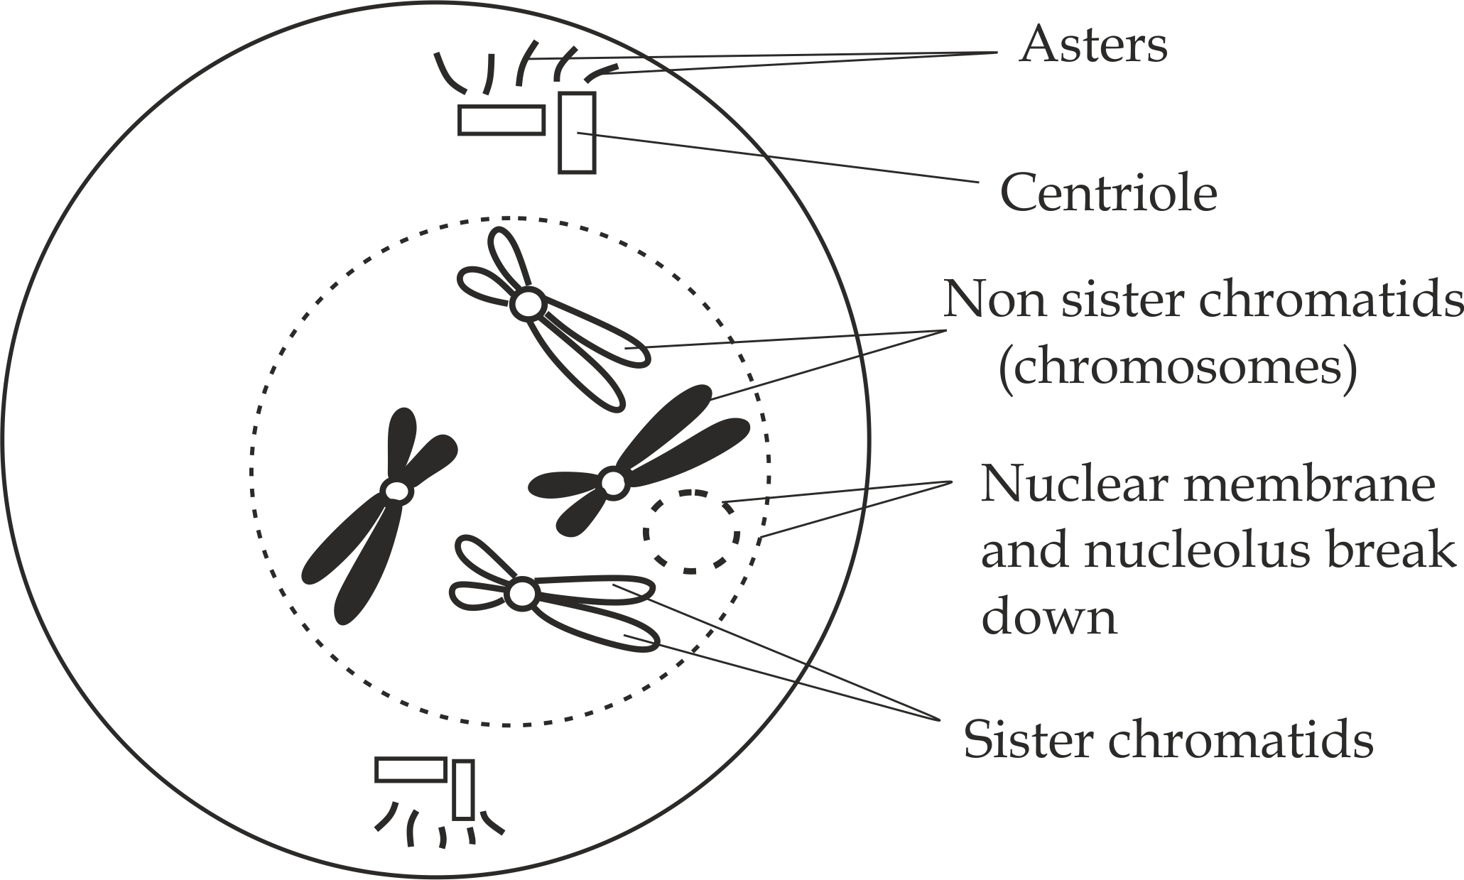

**Figure 4.3** Prophase stage of mitosis

1. **Metaphase**

**Metaphase** is a second stage of mitosis which is characterized by the following events as shown in Figure 4.4.

* The nucleolus and nuclear membrane disappear completely.
* The chromosomes align at the equator of the spindle fibres.
* The spindle fibres attach chromosomes at the centromere.

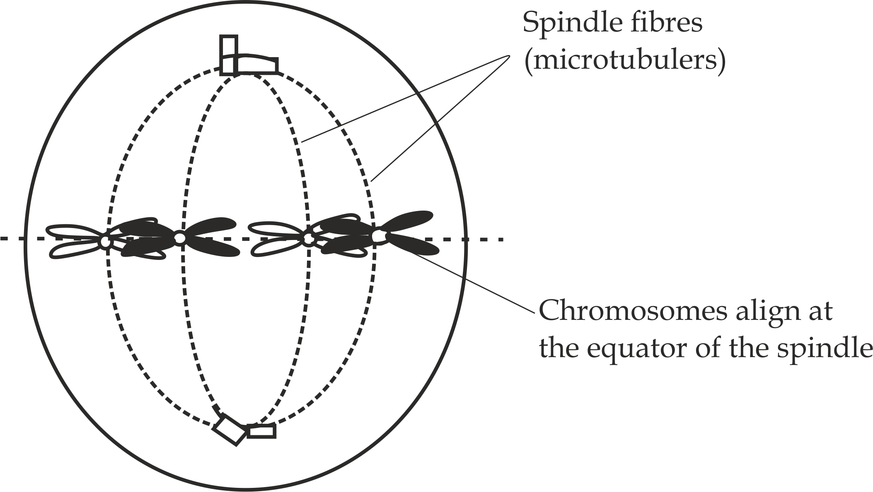

**Figure 4.4** Metaphase stage of mitosis

1. **Anaphase**

**Anaphase** is the most rapid phase of mitosis which is characterized by the following events as shown in Figure 4.5.

* The spindle fibres shorten and pull the sister chromatids to the opposite poles.

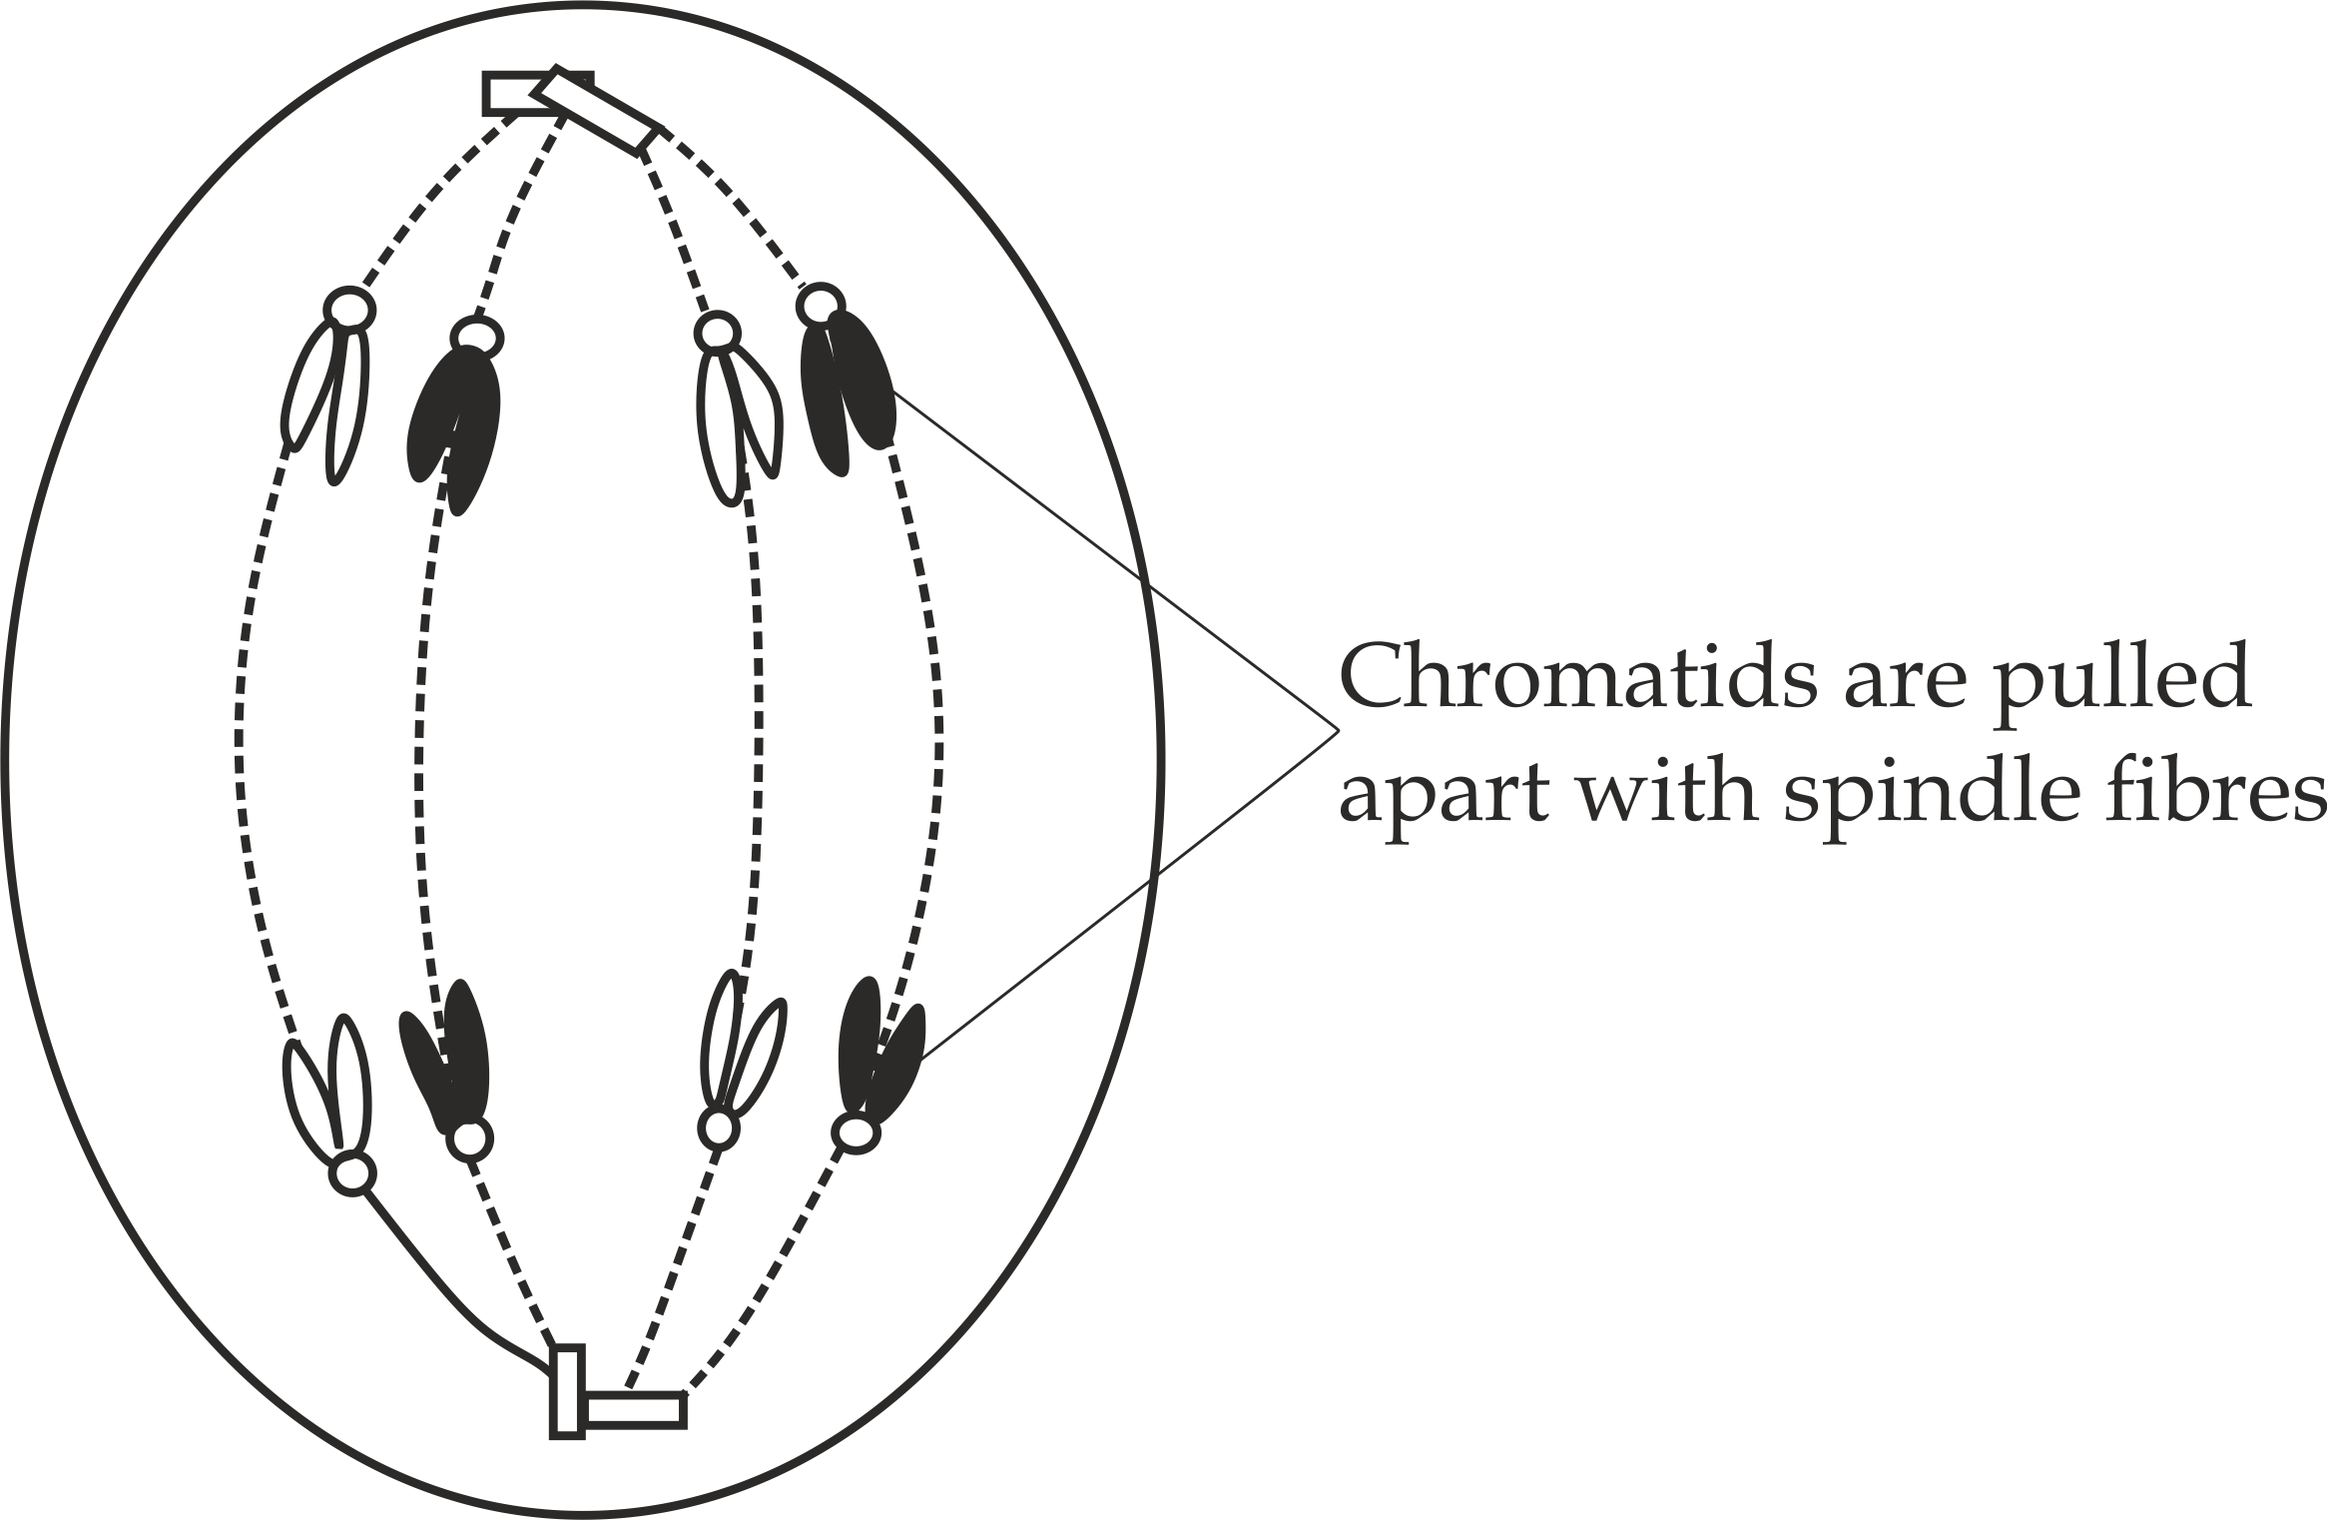

**Figure 4.5** Anaphase stage of mitosis

1. **Telophase**

This is the last phase of mitosis which is characterized by the following events as shown in Figure 4.6.

* The chromatids reach the poles of the cell, uncoil and lengthen to form chromatins.
* Spindle fibres disintegrate and centrioles replicate.
* Nuclear membrane and nucleolus reappear.
* Cytokinesis begins.

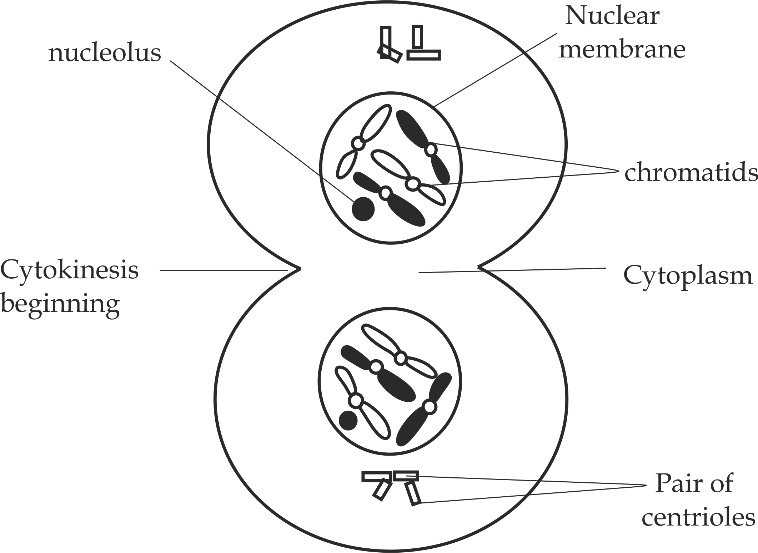

**Figure 4.6** Telophase of mitosis

**SAQ 4.3**

**DAR MOCK 2019**

* With the help of diagrams, describe the events take place in animal cells during four mitotic stages.

***Cytokinesis***

**Cytokinesis** is a process by which the cytoplasm is divided into two separate daughter cells. It begins after telophase stage. Cytokinesis in plants and animal cells is different because of their cytological difference. **In animal cells,** cytokinesis starts by the constriction of the cell surface membrane from outside inward to form cleavage furrows, as the constriction continues to deepen towards the centre, the membranes fuse and pinches off into two separate daughter cells as shown in Figure 4.7(a).**In plant cells**, there is no constriction of the plasma membrane due to the presence of a rigid cell wall. Thus, cytokinesis in plant cells start with the fusion of Golgi vesicles to form a cell plate at the equatorial region between the two newly formed daughter nuclei as indicated in Figure 4.7(b) which finally develops into the primary cell wall which separate two daughter cells.

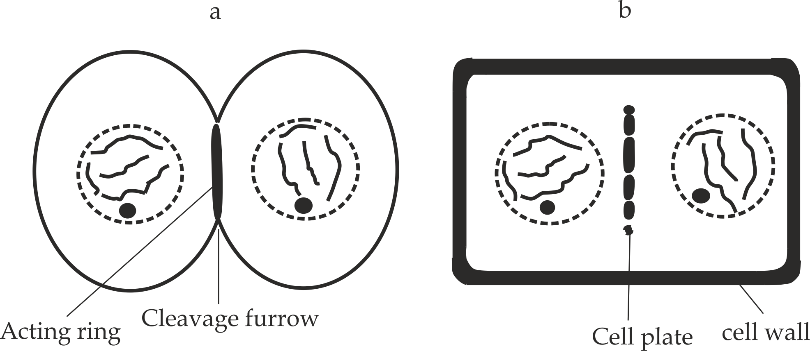

**Figure 4.7** Cytokinesis in (a) animal cell and (b) plant cell

**SAQ 4.4**

**DAR MOCK 2021**

* With the help of diagram, explain how cytokinesis in plants and animals differ.

**Table 4.2 Differences between mitosis in plants and animals**

|  |  |
| --- | --- |
| **Mitosis in plant cells** | **Mitosis in animal cells** |
| Centrioles are absent | Centrioles are present |
| No asters formation | Asters are formed |
| Occurs mainly in meristems | Occurs in tissues throught the body |
| Cytokinesis occurs by the formation of cell wall | Cytokinesis occurs by furrowing of cytoplasm |
| Cell plate grows centrifugally | Cleavage proceeds centripetally |
| Plant cells do not change shape before division | Animal Cell become rounded before cell division. |

**SAQ 4.5**

**DAR MOCK 2021**

* Give four difference between mitosis in plant and in animal.

**4.3 MEASUREMENT OF GROWTH**

Growth is estimated by measuring a particular parameter such as height or mass at suitable intervals over a period of time. The most common parameters used in the measurement of growth are linear dimension and mass.The linear dimension includes height, length, volume or area Fig 4.8 of an organism. Its advantage is that it takes no account of growth in other directions, for this case mass is often used.

***Fresh mass V. dry mass***

**Fresh mass** is a mass of an organism under normal condition; it is the mass of an organism together with the water it contains.

**Advantages of fresh mass**

* It is simple to measure.
* It does not involve the killing of an organism.

**Disadvantage of fresh mass**

* It is not accurate due to temporary fluctuation of water contents in the cells**.**

**Dry mass** is a mass of an organism after removing all water contents in the cells by heating at 110 º C. This technique is commonly adopted with plants.

**Advantage of dry mass**

* It is accurate method.

**Disadvantages of dry mass**

* It is difficult to measure.
* It is a destructive method, since it involves the killing of an organism.

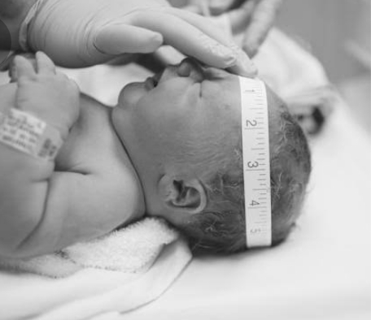

**Figure 4.8** a child is measured head circumference (area) to estimate growth.

**SAQ 4.6**

**NECTA 2007**

* When measuring growth in a living organism, what are the advantages and disadvantages of fresh mass and dry mass?

**4.4 FACTORS AFFECTING GROWTH**

The factors affecting the rate of growth can be divided into two categories – **internal** and **external factors**.

***Internal factors***

These are organisms based factors which include the following:

**Growth hormones**

The rate of growth is depending on the presence or absence of growth hormones, for example auxins, gibberellins and cytokinin affect the rate growth in plants; whereby somatotrophin and thyroxin affect the rate of growth in animals Fig 4.9 an exceptionally tall woman due to excessive production of pituitary growth hormone during childhood.

**Genetic factors**

The rate of growth is also depend on the genetic makeup which influence the growth hormones.

**State of health**

The healthier body grows faster than the diseased body.

***External factors***

These are environmental based factors which include the following:

**Nutrients availability**

Efficient and better supply of nutrients ensure better and rapid growth. Example, lack of protein in human may lead to ***protein deficiency disorder*** *(Kwashiorkor)* whose one of its symptom and sign is stunted growth Fig 4.10 show a child suffering from kwashiorkor which is much common in developing countries.

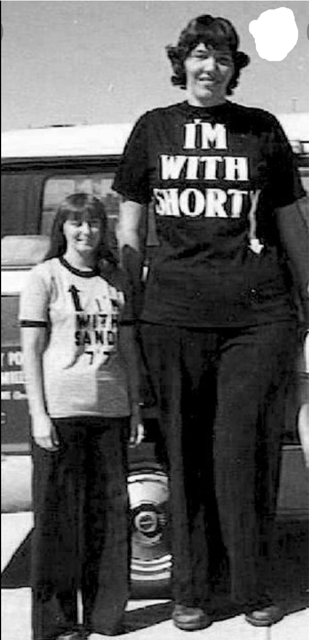

**Figure 4.9** shows the Sandra Elaine Allen was an American woman recognized by the Guinness World records as the tallest woman in the world. She was 231cm tall in 2008.

N

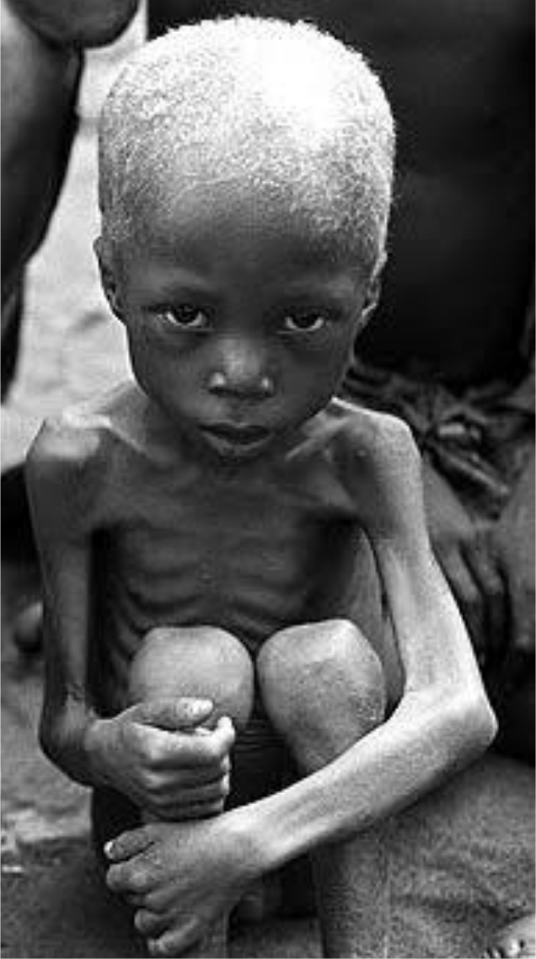

**Fig 4.10** this child is suffering from protein deficiency disorder (**kwashiorkor**).

**Temperature**

This is very important external factor which control growth. All biological processes including growth are accelerated as temperature rises to optimum point for the enzymes to work best. When the temperature is below or above the optimum point the rate of growth is decelerated.

**Light**

This is one of the most important external factors influencing plant growth. Light is directly essential to the growth of photosynthetic plants since it supplies energy by which all new tissues are synthesized.

**Accumulation of metabolic wastes**

This factor has a profound effect on the growth of microorganisms such as bacteria and yeast. Growth can be inhibited by the presence of toxic wastes which are formed as by-products of metabolism.

**SAQ 4.7**

**NECTA 2008**

* State any three (3) factors which influence growth in animals.

**4.5 PATTERNS OF GROWTH**